Cairo University  
Faculty of Computers and Artificial Intelligence



**CS251**

**Software Engineering I**

Version 0.0

|  |  |  |
| --- | --- | --- |
| Team Names | Emails | Phone number |
| Abdelrahman Gamal Abdelrahim | [Abdogamalrahim@gmail.com](mailto:Abdogamalrahim@gmail.com) | 01145019936 |
| Habeba Osama Elsayed | habebaosama742@gmail.com | 01128767153 |
| Hassan Ragab Hassan | Hassanragab776@gmail.com | 01014550937 |

June, 2021

Contents

Instructions [To be removed] 3

Team 3

Document Purpose and Audience 3

System Models 3

I. Class Diagram(s) 4

II. Class Descriptions 5

III. Sequence diagrams 6

Class - Sequence Usage Table 7

IV. State Diagram 8

Tools 9

Ownership Report 9

# Instructions [To be removed]

# Team

Version 0.0

|  |  |  |
| --- | --- | --- |
| Team Names | Emails | Phone number |
| Abdelrahman Gamal Abdelrahim | [Abdogamalrahim@gmail.com](mailto:Abdogamalrahim@gmail.com) | 01145019936 |
| Habeba Osama Elsayed | habebaosama742@gmail.com | 01128767153 |
| Hassan Ragab Hassan | Hassanragab776@gmail.com | 01014550937 |

# Document Purpose and Audience

This document is for explaining the GoFo project and talk about the steps of it and what it contains with no talking about the implementation or coding.

It will explain the steps of the project and its use and the quality of it and its requirements and functionality and It will contain models and graphs explaining the project like use case model and navigation map.

It will contain user stories also.

This document is targeted to project manager the developers working on this project to understand what the project contains. And to users who find it difficult to understand the application

# System Models

## I. Class Diagram(s)

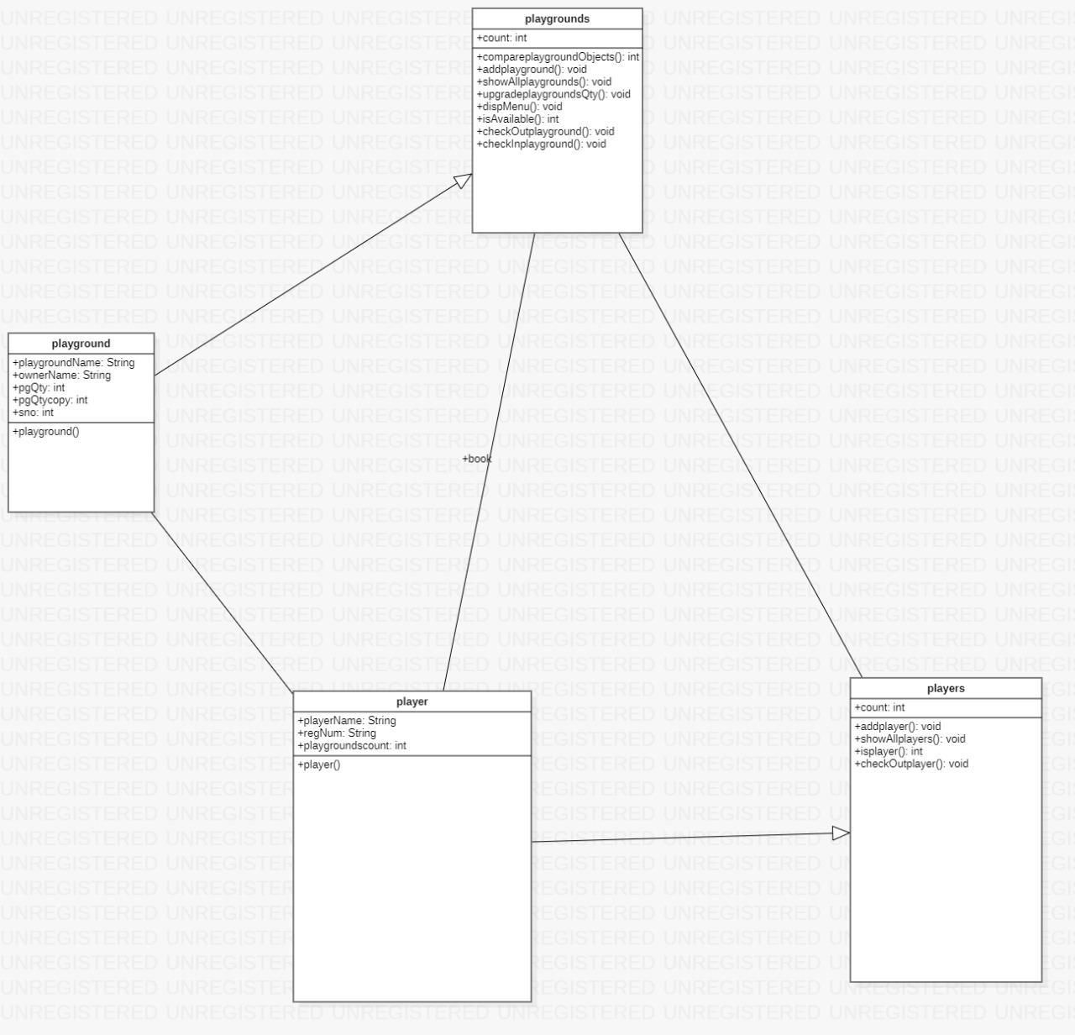

## II. Class Descriptions

| **Class ID** | **Class Name** | **Description & Responsibility** |
| --- | --- | --- |
| 1. | Playgrounds | Check if the playground exit before or not, add a new playground, show all the date about the playground, check availability,  Upgrade playground, Enter Serial No of playground to be sign in, check in playground |
| 2. | playground | Enter playground name and owner name. |
| 3. | player | Enter the players name |
| 4. | players | Allowed to add player, Displays the names of all players and their number, return index number of player if available, allowed to check out the playground |

## 

## III. Sequence diagrams

1- Sequence diagram for registration

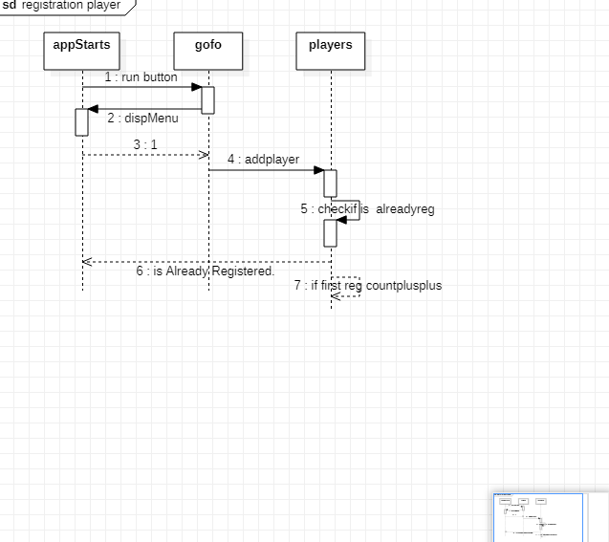

### 

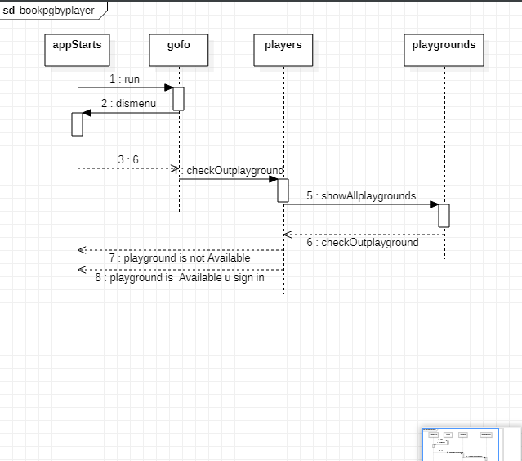2- Sequence diagram for booking playground

### Class - Sequence Usage Table

3- Sequence diagram for adding playground

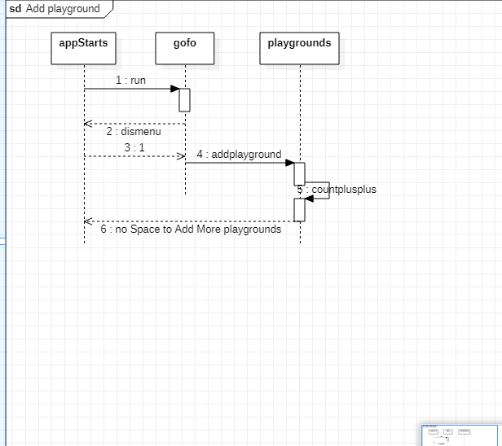

4- Sequence diagram for managing playground

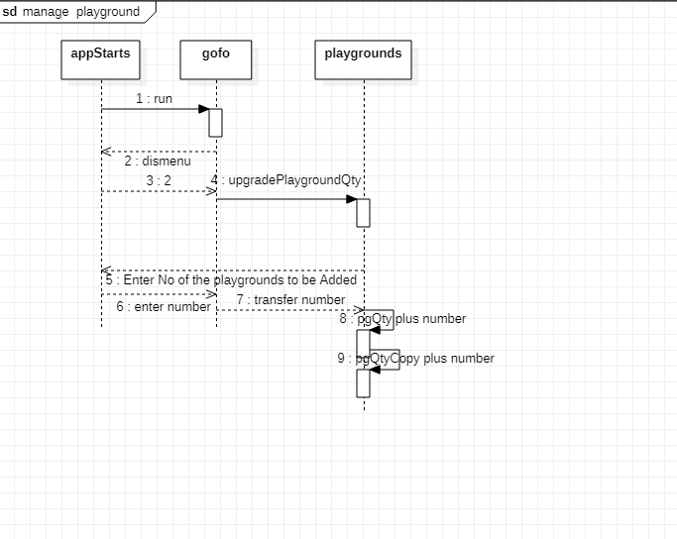

| **Sequence Diagram** | **Classes Used** | **All Methods Used** |
| --- | --- | --- |
| 1. Registration | Class players{ }  Class player{ }  class gofo{ } | public void addplayer(player s); |

| **Sequence Diagram** | **Classes Used** | **All Methods Used** |
| --- | --- | --- |
| 1. Booking playground by player | Class players  class player  Class playgrounds  class gofo | checkOutplayground(playgrounds pg);  showAllplaygrounds(); |

| **Sequence Diagram** | **Classes Used** | **All Methods Used** |
| --- | --- | --- |
| 3-Add playground | Class playgrounds  class gofo | public void addplayground(playground b) |
| 4-Manage playground by the owner | Class playgrounds  class playground  class gofo | upgradePlaygroundQty(); |

## 

## IV. State Diagram

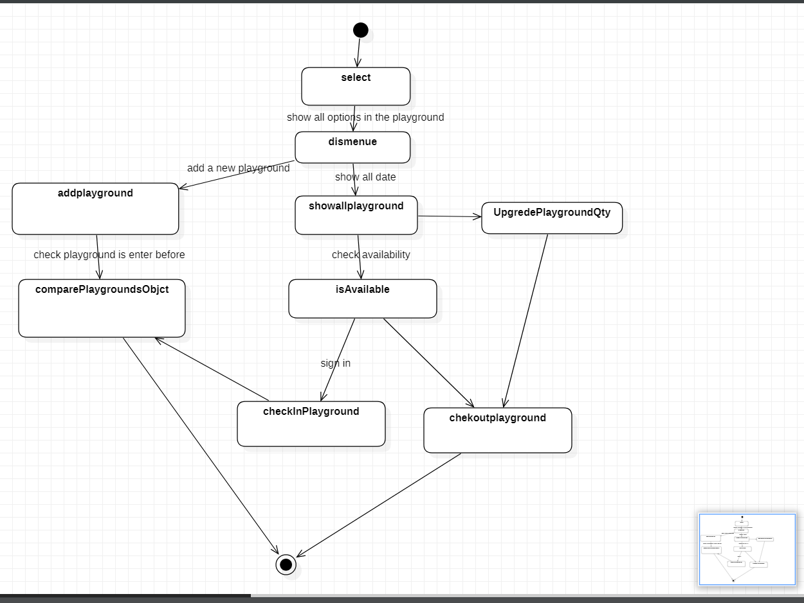

# 

# Tools

StarUML.

# 

# Ownership Report

|  |  |
| --- | --- |
| **Student** | **Items he/she created** |
| **Abdelrahman Gamal Abdelrahim** | **Class Diagram** |
| Habeba Osama Elsayed | Class Description |
| Hassan Ragab Hassan | Sequence Diagram |